ASSIGNMENT 1

Ques1: Explain the difference between frontend, backend, and full-stack development with suitable real-world examples.
Answer1:
Frontend Development | Backend Development | Full-Stack Development
Focuses on the user interface (UI) that users interact with. | Handles server-side logic, databases, and application functionality. | Works on both frontend and backend development.
Uses HTML, CSS, JavaScript, React, Angular, etc. | Uses Java, Python, PHP, Node.js, C#, etc. | Uses a combination of frontend and backend technologies.
Ensures the website is attractive and responsive. | Processes requests, manages data, and handles authentication. | Develops complete web applications from start to finish.
Real world Examples:
- Frontend: Displays product images, prices, search bar, and shopping cart.
- Backend: Processes orders, stores customer details, manages payments, and updates inventory.
- Full-Stack Developer: Can build both the shopping interface and the server-side order processing system.

Ques2 : Create a simple diagram showing how the client-server model works in web architecture.
Answer2:
Client (Browser)
(Chrome, Firefox, Edge)
|
HTTP/HTTPS Request
|
▼
Web Server (Apache/Nginx)
|
Processes Request
|
▼
Database Server
(MySQL/PostgreSQL)
|
Sends Requested Data
|
▲
HTTP Response
|
▼
Client Displays
Web Page
Ques3 : Describe how a browser requests and displays a web page from a web server.
Answer 3:
When a user enters a website URL into a web browser, the browser communicates with a web server to retrieve and display the requested webpage. The process is as follows:
- Enter the URL: The user types a website address (e.g., www.example.com) into the browser and presses Enter.

- DNS Lookup: The browser contacts the Domain Name System (DNS) to translate the website's domain name into its corresponding IP address.

- Send HTTP/HTTPS Request: Using the IP address, the browser sends an HTTP or HTTPS request to the web server asking for the webpage.

- Server Processes the Request: The web server receives the request. If the page requires dynamic content, the server retrieves the necessary data from the database and generates the webpage.

- Server Sends the Response: The web server returns the requested files, such as HTML, CSS, JavaScript, images, and other resources, to the browser.

- Browser Renders the Page: The browser reads the HTML structure, applies CSS styles, executes JavaScript, and downloads additional resources like images and fonts.

- Web Page is Displayed: After all resources are processed, the browser displays the fully rendered webpage, allowing the user to interact with it.

Ques 4: Identify and list the tools required to set up a web development environment. Explain the purpose of each.
Answer 4:
Tool | Purpose
Visual Studio Code | Source code editor for writing HTML, CSS, JavaScript, etc.
Google Chrome | Browser used for testing web pages.
Live Server Extension | Automatically reloads the webpage after code changes.
Node.js | JavaScript runtime for backend development.
Git | Version control system to track code changes.
GitHub | Online platform for storing and sharing code repositories.
Web Browser Developer Tools | Helps inspect HTML, CSS, JavaScript, and debug websites.
Ques 5: Explain what a web server is and give examples of commonly used servers.
Answer 5:
A web server is software or hardware that stores website files and delivers them to users' browsers over the internet using HTTP or HTTPS.
Common Web Servers
- Apache HTTP Server
- Nginx
- Microsoft IIS
- LiteSpeed
- Apache Tomcat

Ques 6: Define the roles of a frontend developer, backend developer, and database administrator
Answer 6:
Frontend Developer
- Designs the user interface.
- Creates responsive layouts.
- Implements HTML, CSS, and JavaScript.
- Improves user experience.
Backend Developer
- Develops server-side logic.
- Creates APIs.
- Handles authentication and security.
- Connects the application to databases.
Database Administrator (DBA)
- Designs database structure.
- Maintains and secures databases.
- Performs backups and recovery.
- Optimizes database performance.

Ques7: Install VS Code and configure it for HTML, CSS, and JavaScript development. Take a screenshot of the setup.
Answer 7
Installation Steps:
- Download Visual Studio Code from the official website.
- Install the software using the default settings.
- Launch VS Code.
- Install the following extensions:
  - Live Server
  - Prettier
  - HTML CSS Support
  - JavaScript (ES6) Code Snippets
- Create a project folder.
- Create the following files:
  - index.html
  - style.css
  - script.js
- Open index.html using the Live Server extension.
- Verify that the webpage opens successfully in the browser.
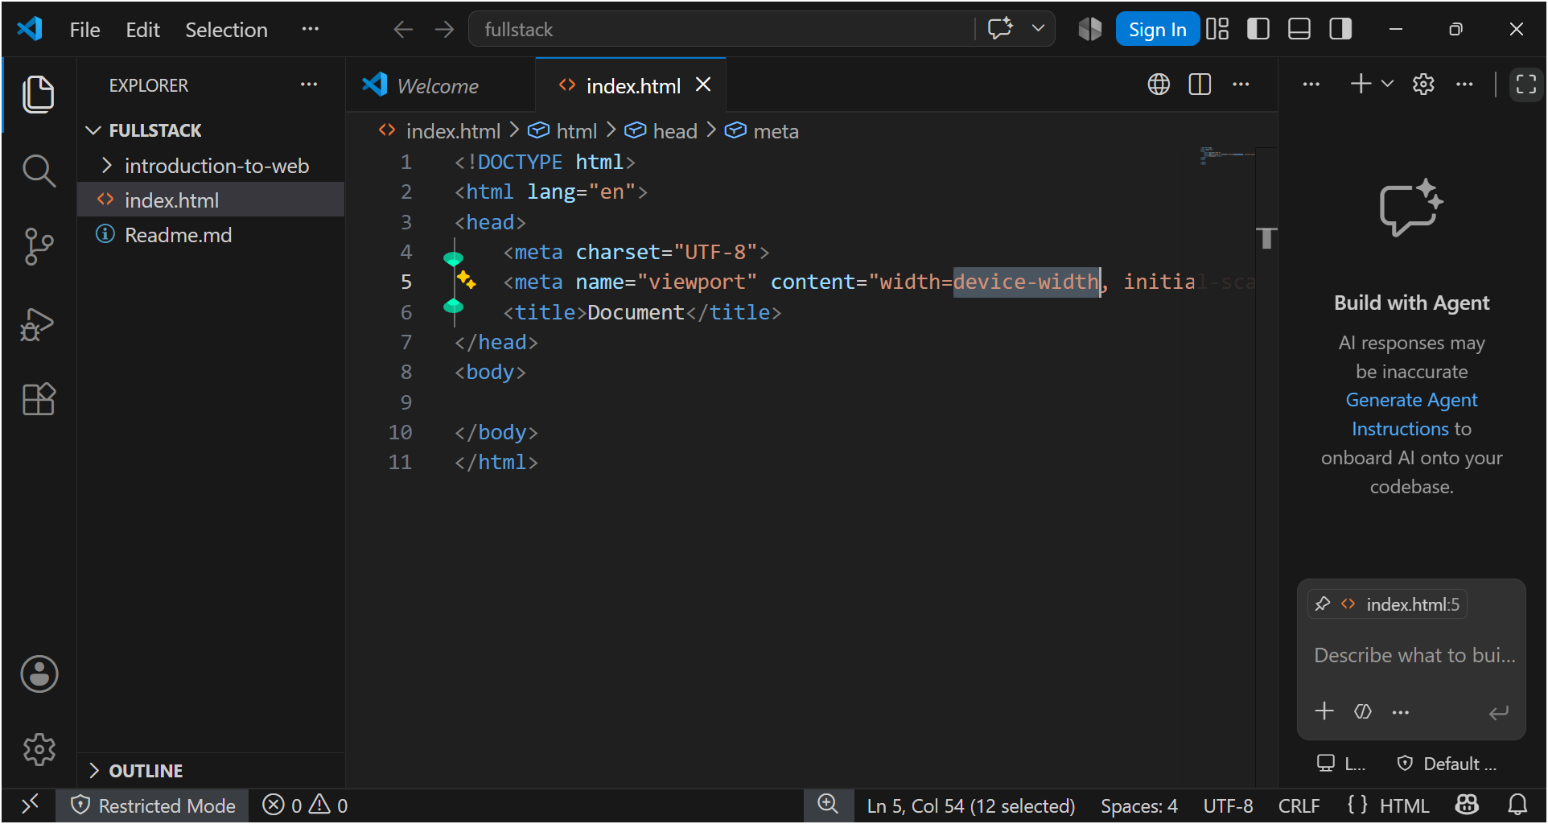

Ques 8: Explain the difference between static and dynamic websites. Provide an example of each.
Answer 8:
Static Website | Dynamic Website
Fixed content. | Content changes based on user interaction or database.
Does not require a database. | Usually connected to a database.
Faster loading. | More interactive and feature-rich.
Easy to develop. | More complex to develop.

Examples
Static Website
- Personal Portfolio
- Company Landing Page
Dynamic Website
- Facebook
- Amazon
- Instagram
- Online Banking Website

Ques 9: Research and list five web browsers. Explain how rendering engines differ between them.
Answer 9:
Browser | Rendering Engine
Google Chrome | Blink
Microsoft Edge | Blink
Mozilla Firefox | Gecko
Apple Safari | WebKit
Opera | Blink

Rendering Engine Differences
- Blink: Fast rendering, widely used in Chromium-based browsers.
- Gecko: Developed by Mozilla, emphasizes web standards and privacy.
- WebKit: Used by Safari, optimized for Apple devices with efficient performance.

10. Draw a labeled diagram showing the basic web architecture flow — client, server,
database, and API

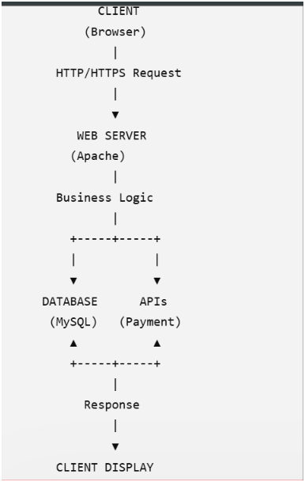
- Client (Browser): The user accesses the website through a web browser.
- Request: The browser sends an HTTP/HTTPS request to the web server.
- Web Server: The server processes the request and handles the application's logic.
- Database: The server retrieves or stores data in the database if required.
- APIs: The server interacts with external services (such as payment or map APIs) when needed.
- Response: The server sends the processed data back to the browser.
- Client Display: The browser displays the requested webpage to the user.
Flow:
Client → Web Server → Database/APIs → Response → Client Display

